Task3

1)To get the ip address of a particular domain(guvi.in). To find my CPU/memory usage of my server. To test the connectivity between two nodes.

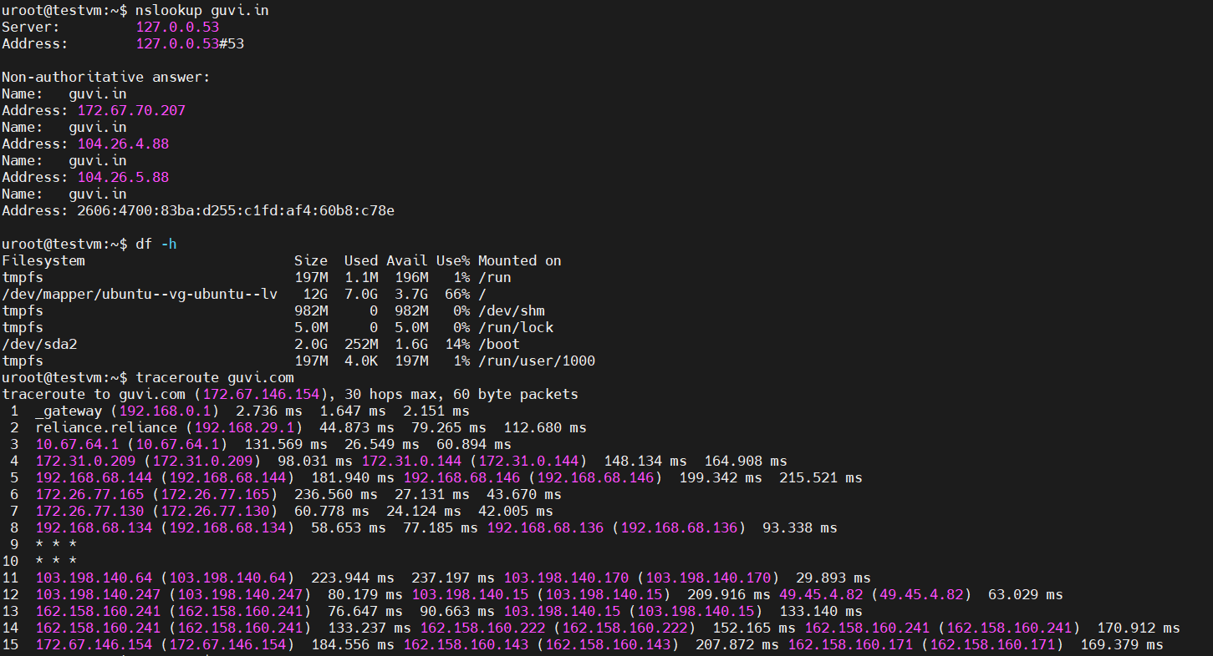

2) I have deployed an application in guvi.com:9000, and logs show my app is running, but I’m unable to view the page. To Check whether my port is open or not?

